 | KiCAD PORTFOLIO  TRAVOLTA CHIPOSI-MUDIWA (he/him/his)  MSE, Mechanical Engineering | Johns Hopkins University | Baltimore MD, USA (May 2027)  B-Tech Honors, Electronic Engineering | Harare Institute of Technology | Harare, ZWE (Oct 2024)  410 814-1812 | tchipos1@jh.edu | LinkedIn | Github

CONTENTS
DESIGNS 1
STM32 MICROCONTROLLER & GPS TECHNOLOGY PCB 1
STM32 MICROCONTROLLER PCB (STM 32F1-03C8T6 BLUE PILL) 1
LI-PO_BATTERY_CHARGER (MCP73831) 4
INTRODUCTION TO KICAD PROJECT 6

DESIGNS

STM32 MICROCONTROLLER & GPS TECHNOLOGY PCB - 4 LAYERS
- STM32CubeIDE used for comprehensive pinout descriptions.
- STM32F1-xx-XX-xx : the F represents the series, the 1 represents the power, and it increases upwards while the xx-XX-xx represents the package size ie pins, RAM etc.

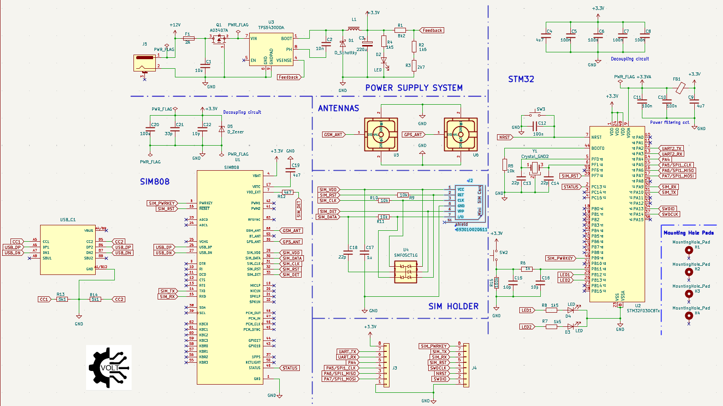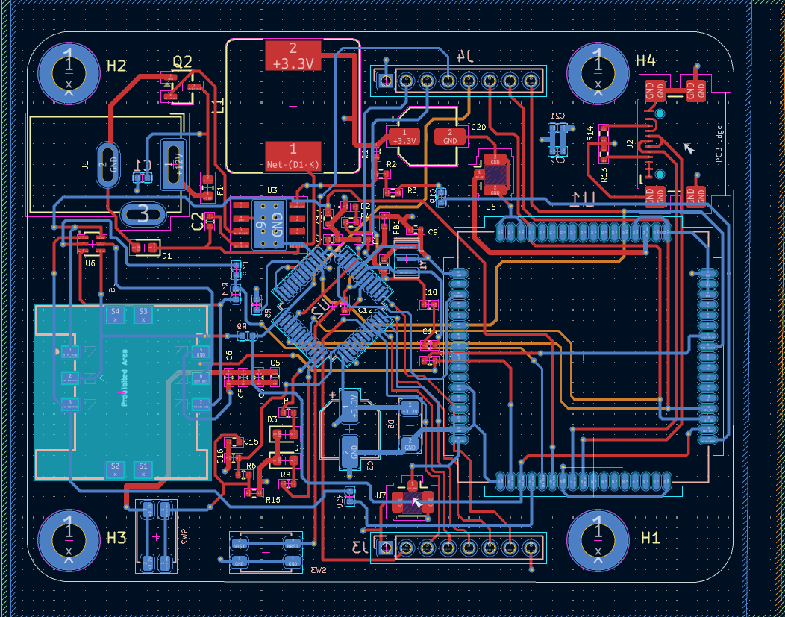

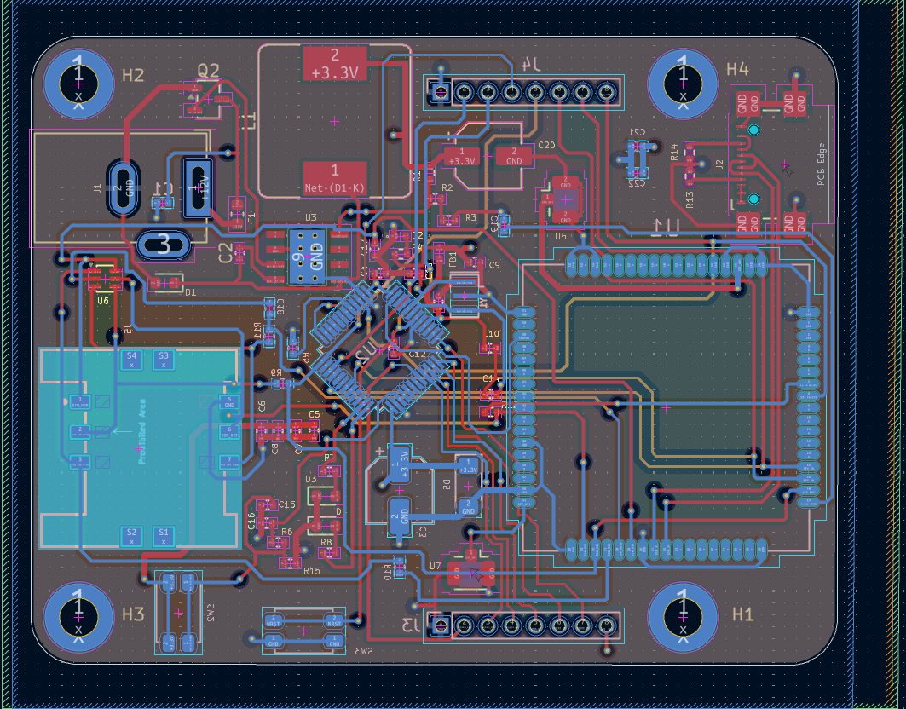
TOP
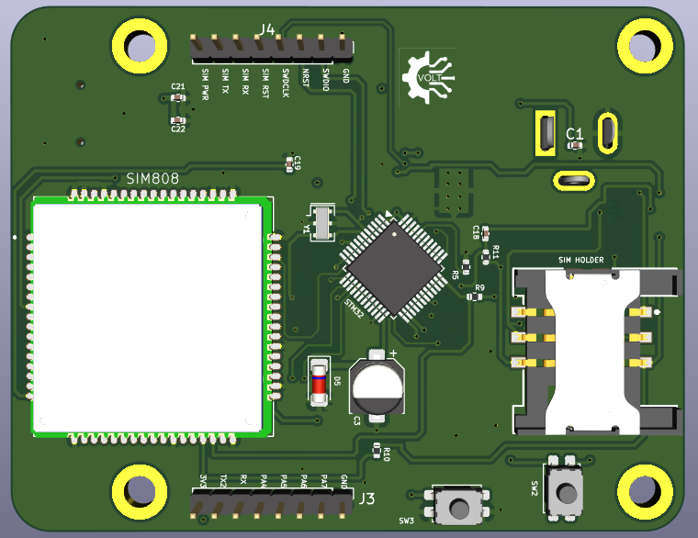

BOTTOM
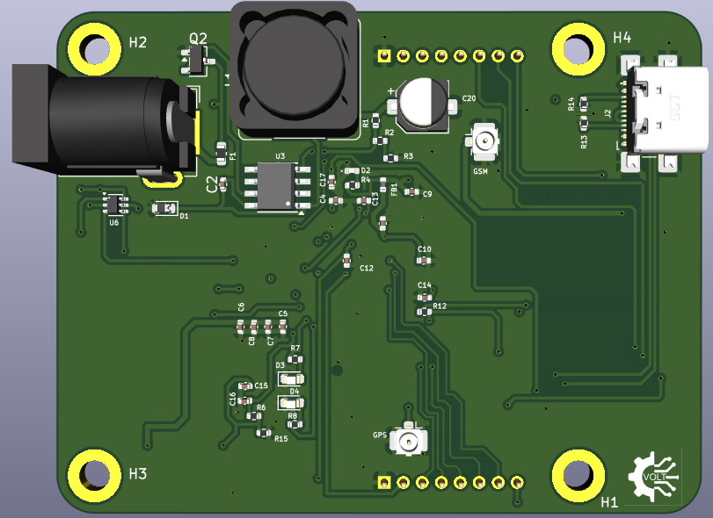
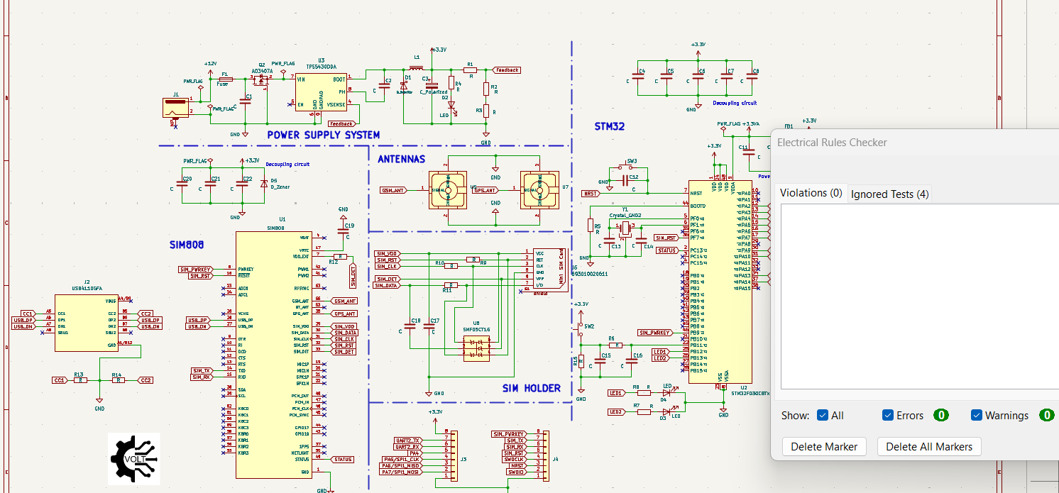
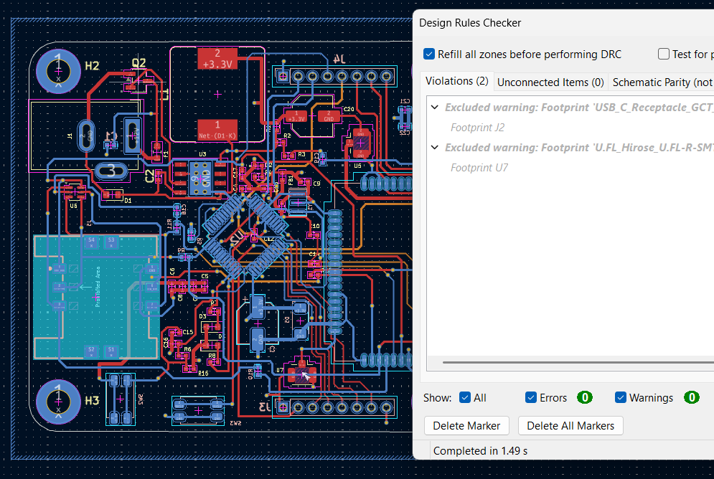

STM32 MICROCONTROLLER PCB (STM 32F1-03C8T6 BLUE PILL) - 2 LAYERS
- STM32CubeIDE used for comprehensive pinout descriptions.
- STM32F1-xx-XX-xx : the F represents the series, the 1 represents the power and it increases upwards while the xx-XX-xx represents the package size ie pins, RAM etc.
- VSSA : ground for the analog side of the controller, VSS - ground for the digital side of the controller.
- VDD : main system power supply (2.7 V -3.6 V), VBAT - used when real-time clock of the controller is in use and also when there is an external battery pack
- Decoupling capacitors (general and bulk): positioned close to the IC to provide localized energy storage in times of IC switching, 1 per each power pin.
- VDDA : power supply for the analog sections of controller, needs more filtering (through a resistor, inductor or ferrite bead - given a typical resistance at 100 MHz) because analog signals are quite sensitive to noise.
- NSRT : negative reset pin (reset with inverted logic) if pulled low, it will put MCU into RESET MODE, recommended to pull HIGH so the MCU boots whatever it’s flashed with.
- BOOT0 : enables or disables the bootloader for STM32 MCU. Pull HIGH to enable interfaces like UART, I2C to program the MCU (with drivers installed) or pull LOW to just use the program already flashed to it currently.
- USB_D- & USB_D+ are called differential pairs; ie pins designated by the same root word and differing on the sign attached

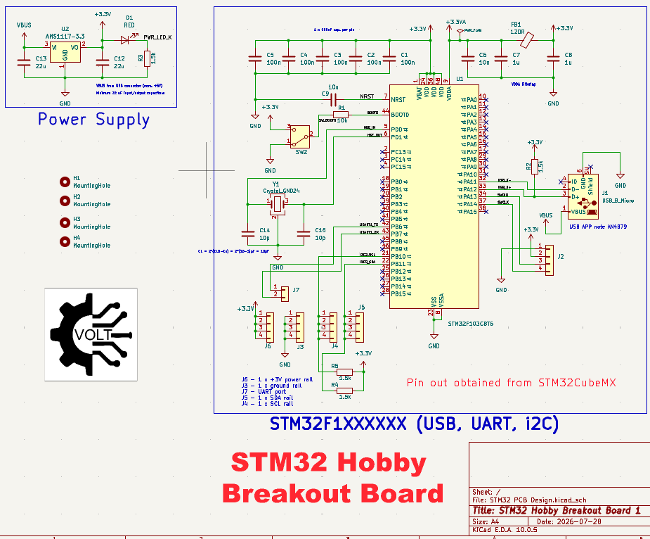
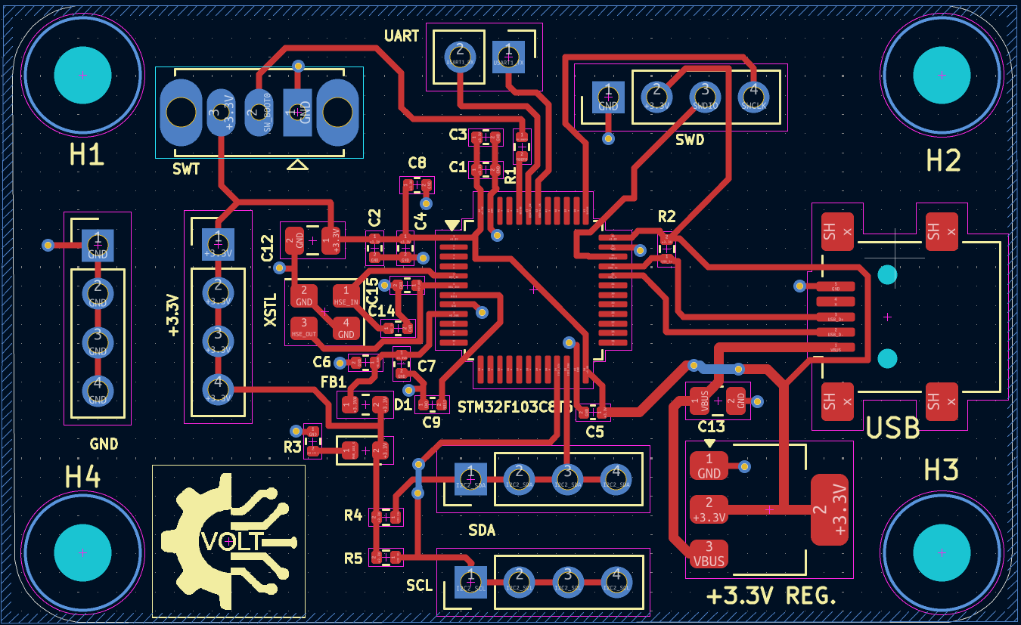
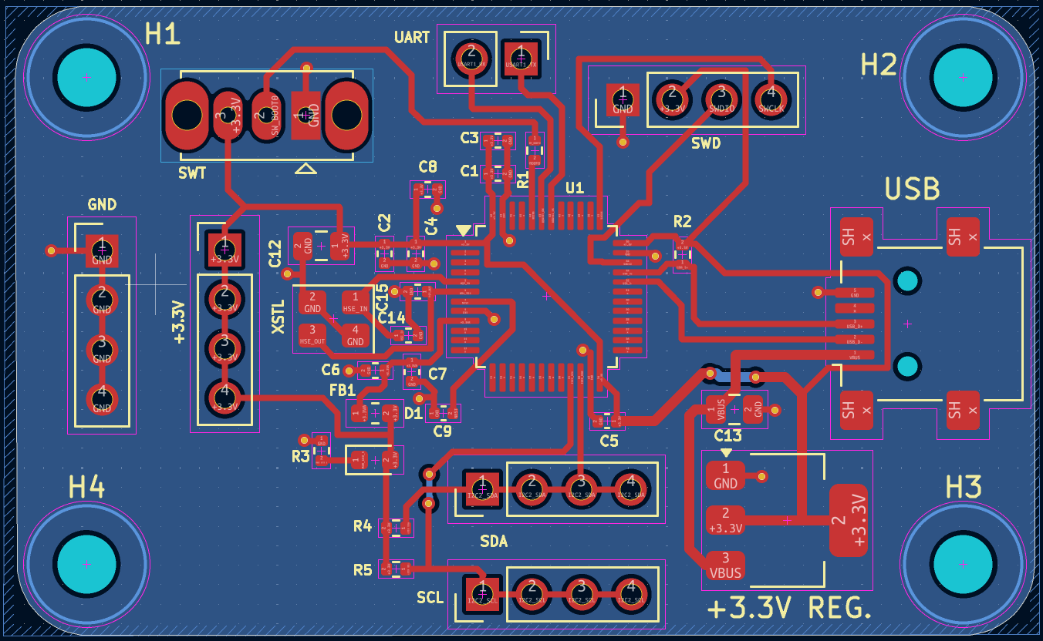
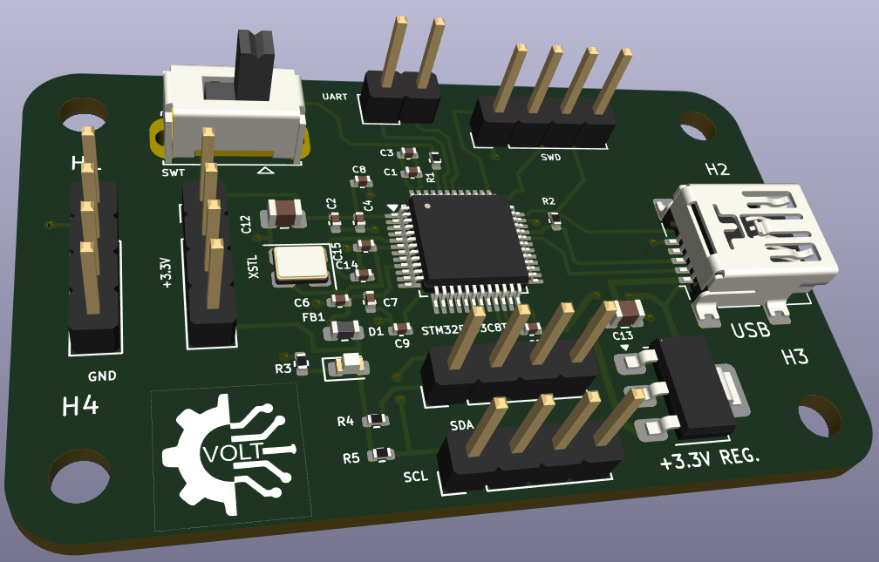

LI-PO_BATTERY_CHARGER (MCP73831)
- x 1, Single-Cell Li-Ion/Li-Po Charge Management Controller, Part: MCP73831T-2ACI/OT or MCP73831
- J2: Battery Connector (JST-PH or 2-pin header), Part: Conn_01x02 or JST_PH
- C1, C2: Surface Mount Ceramic Capacitors, Part: C
- J1: Micro-USB Connector, Part: USB_B_Micro
- R1, R2: Surface Mount Resistors, Part: R
- D1: Status LED

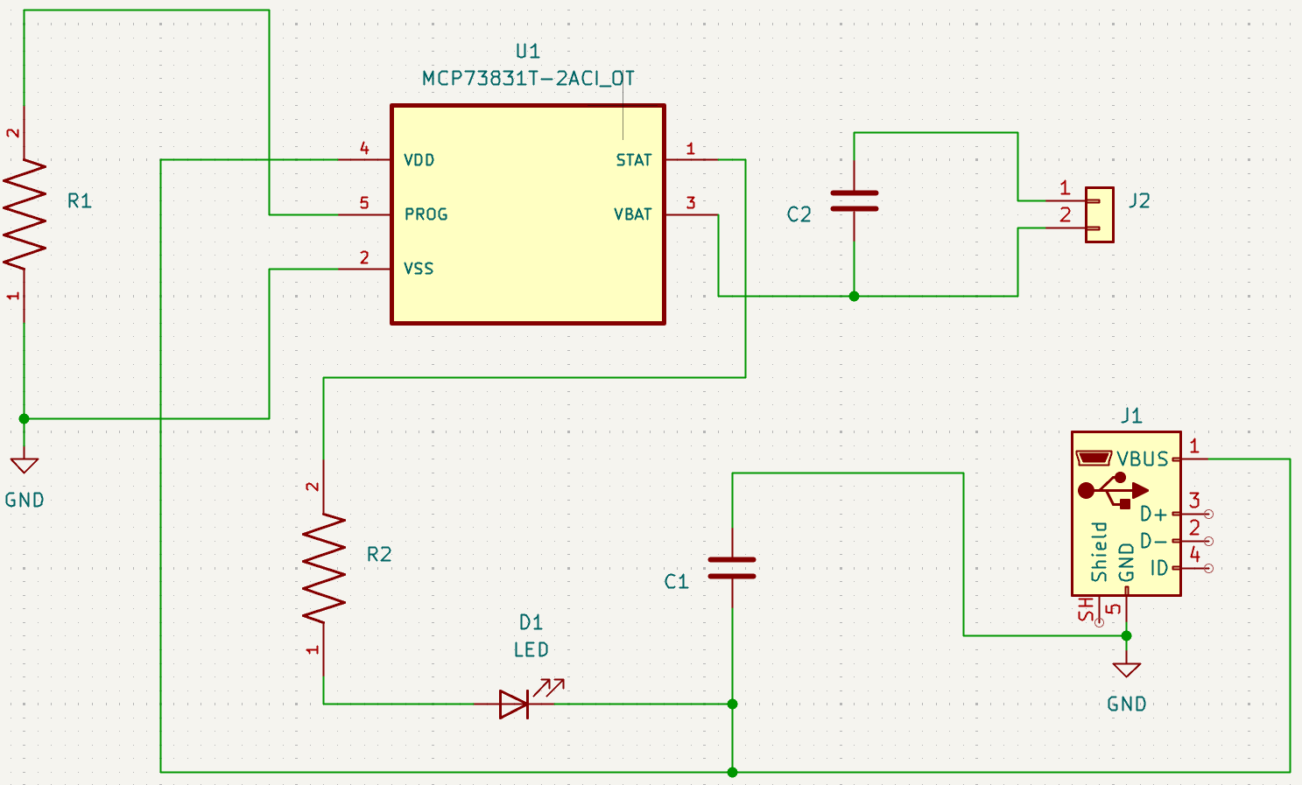 | Note(s):  - Typically 4.7µF to 10µF 0805 MLCC capacitors are placed close to VBUS and VBATT.  - R2 is typically a current-limiting resistor for the LED (0.4 kΩ), and R1 (PROG) sets the charging current (e.g., 2kΩ for 500mA, 10kΩ for 100mA).  - The USB shell is internally connected to the system ground.
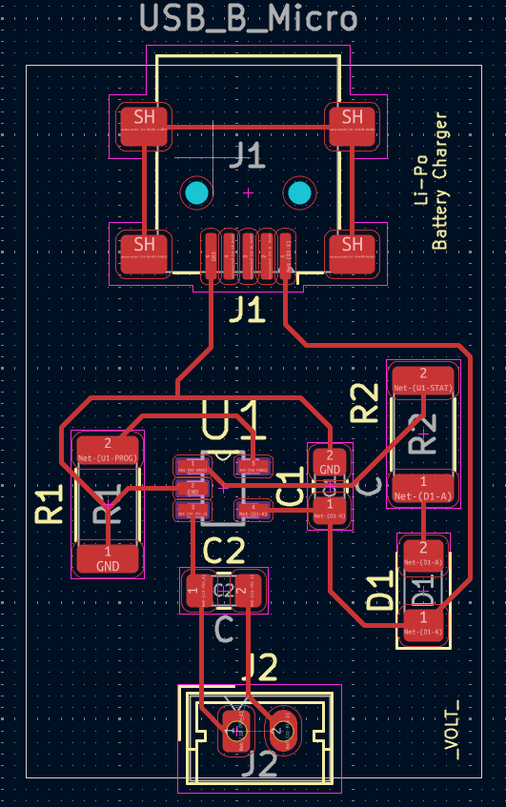 | - No track must make a 90 degree angle at any point.  - Strict adherence to distances between terminals.  - Each component of the PCB at its correct layer.  - Use of datasheets to check the dimensions of components.
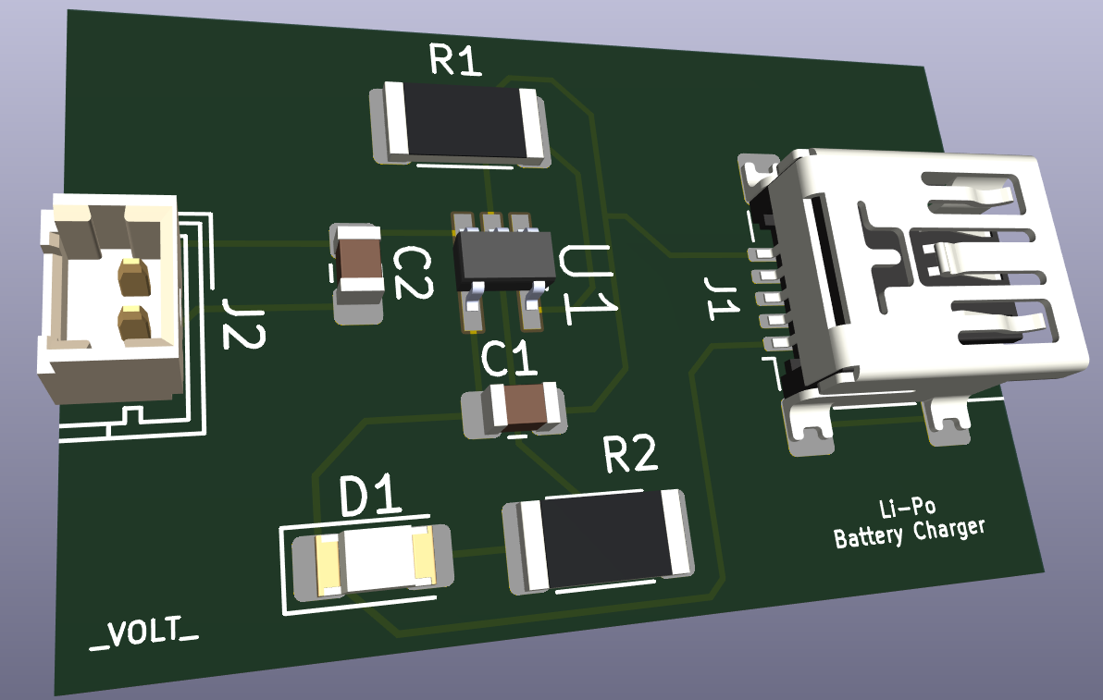 | - 3D packages for components are imported as STEP files into KiCad and used in the relevant project.

INTRODUCTION TO KICAD

- LED, 3 Pole slide switch, Resistor, 2 pin terminal block

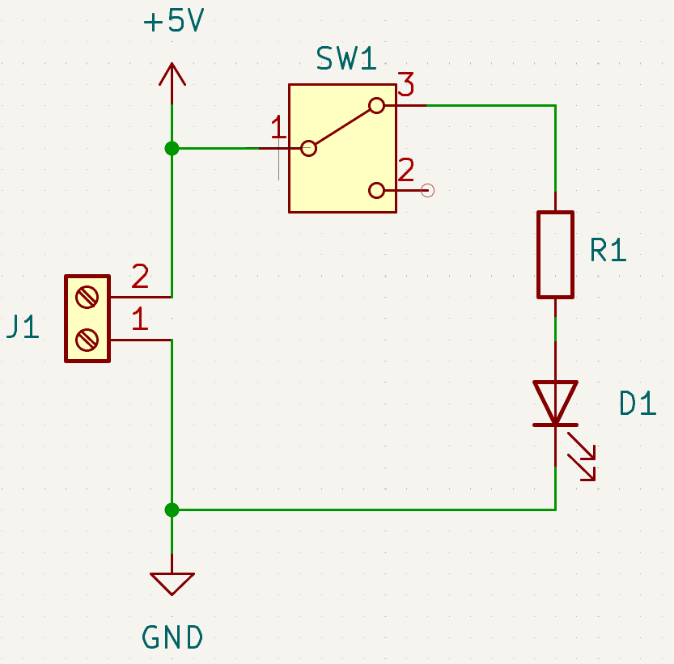
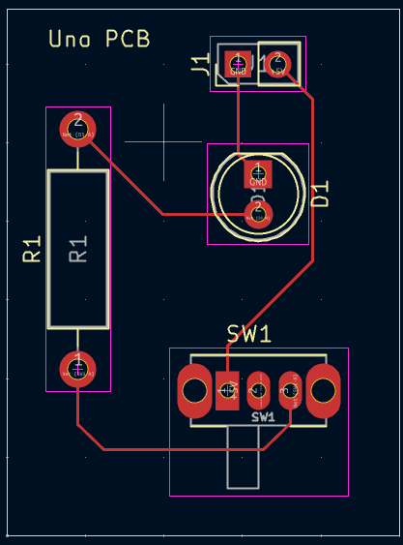 | - No track must make a 90 degree angle at any point  - Strict adherence to distances between terminals  - Each component of the PCB at its correct layer  - Use of data sheets to check dimensions of components
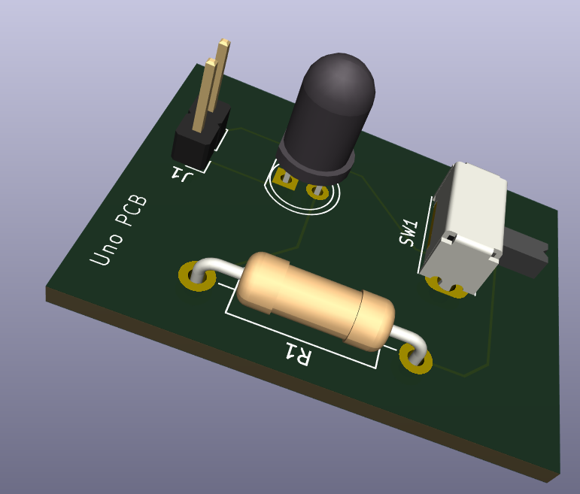

LAYOUT

Organization/Team Name:

Dates: Duration of involvement.

Role: Your specific title (e.g., Team Member, President, Research Assistant).

Overview

A 1-paragraph summary of the project’s goal, the team’s achievements (like competition rankings), and the technical materials/tools used.

Individual Responsibilities

Use bullet points starting with strong action verbs (e.g., "Designed," "Manufactured," "Managed").

Quantifiable Results: Include specific tolerances, weights, or speeds (e.g., "machined to within $\pm 0.001in$").

Soft Skills: Mention communication, funding, or mentoring roles.

Visuals & Links

Media: Include photos of the final product, "action shots" of testing, and CAD/FEA diagrams.

Captions: Label your photos (e.g., "L to R: Me with the prototype...").

External Proof: Provide links to news articles, YouTube videos of tests, or technical papers.

Pro Tip: Use QR codes for links so they are accessible from a printed copy.

4. Technical Deep Dive (Optional)

Sample Write-up: If you have a particularly complex task, include a "Sample Write-up" or "Project Test Report".

Data Visualization: Include graphs (like acceleration vs. time) to show you can analyze and verify your models through testing.

5. Handling Sensitive/Proprietary Work

If you cannot show photos due to NDAs or commercial sensitivity, explicitly state this.

Workaround: Instead of photos of the actual hardware, use generic diagrams, flowcharts of your process, or scripts you wrote (e.g., MATLAB) to show the method without exposing the secret.

